Module 5: Ansible Assignment – 1
Tasks To Be Performed:
1. Setup Ansible cluster with 3 nodes
2. On slave 1 install Java
3. On slave 2 install MySQL server
Do the above tasks using Ansible Playbooks

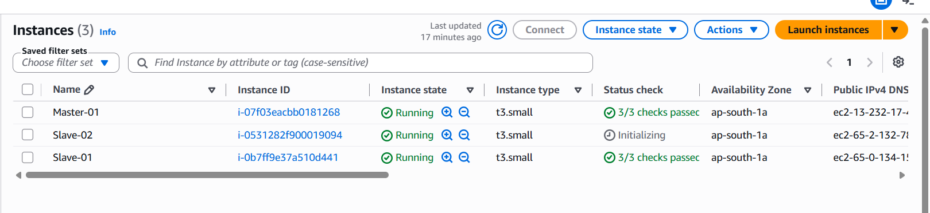
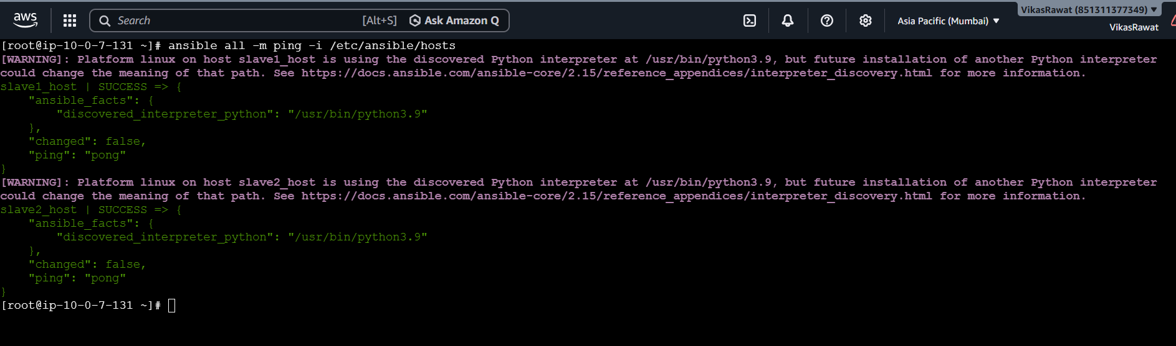

---
# Task 1 & 2: Target Slave 1 and install Java
- name: Install Java on Slave 1
hosts: slave1
become: true
tasks:
- name: Install Java 21 OpenJDK package
dnf:
name: java-21-amazon-corretto-headless
state: present

- name: Verify Java installation
command: java -version
register: java_check
changed_when: false

- name: Print Java Version
debug:
msg: "{{ java_check.stderr_lines }}"

# Task 1 & 3: Target Slave 2 and install Database Server
- name: Install Database Server on Slave 2
hosts: slave2
become: true
tasks:
- name: Install AWS Native MariaDB Server package
dnf:
name: mariadb105-server
state: present

- name: Start and enable Database Service
service:
name: mariadb
state: started
enabled: true

- name: Verify Database installation
command: mysql --version
register: mysql_check
changed_when: false

- name: Print Database Version
debug:
msg: "{{ mysql_check.stdout_lines }}"

